**Assembly Level Program 1a – Binary Search**

Write an Assembly Level Program to search a key element in a list of ‘n’ 16-bit numbers using the Binary Search Algorithm.

**Program**

.model SMALL

.data

ARRAY dW 1234h, 2345h, 3456h, 4567h, 5678h, 6789h

LEN dW ($-ARRAY)/2

KEY dW 6789h

STR1 dB 10, 13, 'Element Found at Position '

POS dB ?, 10, 13, '$'

STR2 dB 10, 13, 'Element Not Found!$'

.code

MOV AX, @DATA

MOV DS, AX

MOV AX, 00h

MOV CX, LEN

MOV DX, KEY

Search:

CMP CX, AX

JB NotFound

MOV BX, CX

ADD BX, AX

SHR BX, 01h ; Divides by 2

MOV SI, BX

SHL SI, 01h ; Multiplies with 2

CMP ARRAY[SI], DX

JB newLow

JE Found

CMP BX, 00h

JE NotFound

DEC BX

MOV CX, BX

JMP Search

newLow:

INC BX

MOV AX, BX

JMP Search

Found:

ADD BL, '1'

MOV POS, BL

LEA DX, STR1

JMP Exit

NotFound:

LEA DX, STR2

Exit:

MOV AH, 09h

INT 21h

MOV AH, 4Ch

INT 21h

END

**Output**

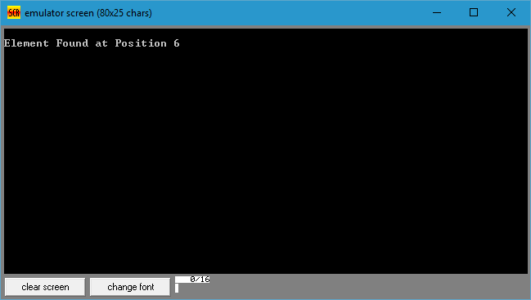

**Assembly Level Program 2a – Reading & Printing String**

Write 2 ALP modules stored in two different files; one module is to read a character from the keyboard and the other one is to display a character. Use the above two modules to read a string of characters from the keyboard terminated by the carriage return and print the string on the display in the next line.

**PrintCharacter.inc**

PRINTCH MACRO CHAR

MOV DL, CHAR

MOV AH, 02h

INT 21h

ENDM

**ReadCharacter.inc**

READCH MACRO

MOV AH, 01h

INT 21h

ENDM

**Program**

.model SMALL

Include ReadCharacter.inc

Include PrintCharacter.inc

.data

LOC dB 100 DUP(0)

STR1 dB 10, 13, 'Enter a String: $'

STR2 dB 10, 13, 'Entered String is: $'

.code

MOV AX, @DATA

MOV DS, AX

MOV CX, 00h

LEA DX, STR1

MOV AH, 09h

INT 21h

LEA SI, LOC

Read:

READCH

CMP AL, 0Dh

JE Display

MOV [SI], AL

INC SI

INC CL

JMP Read

Display:

LEA DX, STR2

MOV AH, 09h

INT 21h

LEA SI, LOC

Print:

PRINTCH [SI]

INC SI

Loop Print

MOV AH, 4Ch

INT 21h

END

**Output**

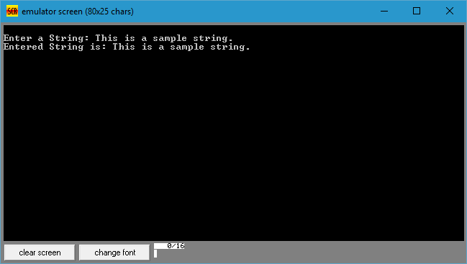

**Assembly Level Program 3a – Bubble Sort**

Write an Assembly Level Program to sort a given set of 'n' numbers in ascending and descending orders using the Bubble Sort algorithm.

**Program**

.model SMALL

.data

ARRAY dB 05h, 07h, 06h, 04h, 10h, 09h

LEN dB $-ARRAY

.code

MOV AX, @DATA

MOV DS, AX

MOV CX, 00h

MOV CL, LEN

DEC CL

OuterLoop:

MOV BX, CX

LEA SI, ARRAY

InnerLoop:

MOV AL, [SI]

INC SI

CMP [SI], AL

JBE NoSwap

XCHG [SI], AL

MOV [SI-1], AL

NoSwap:

DEC BX

JNZ InnerLoop

LOOP OuterLoop

Exit:

MOV AH, 4Ch

INT 21h

END

**Output**

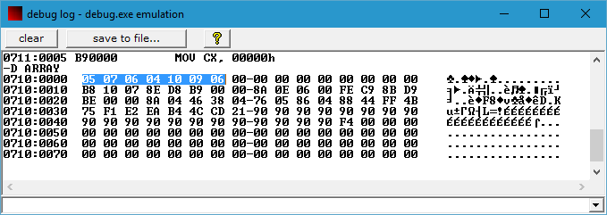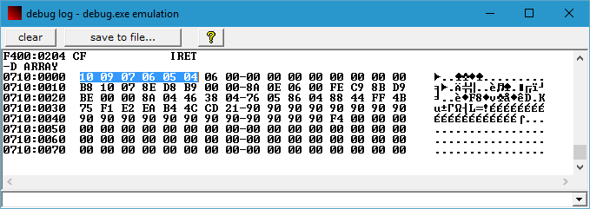

**Assembly Level Program 4a – Bubble Sort**

Write an Assembly Level Program to read an alphanumeric character and display its equivalent ASCII code at the center of the screen.

**Program**

.model SMALL

CLRSCR MACRO

MOV AH, 00h

MOV AL, 03h

INT 10h

ENDM

SETCURSOR MACRO

MOV AH, 02h

MOV BH, 00h

MOV DH, 12d

MOV DL, 39d

INT 10H

ENDM

.data

MSG1 dB 10, 13, 'Enter an alphanumeric character: $'

.code

MOV AX, @DATA

MOV DS, AX

CLRSCR

; Print Message in Data Segment

LEA DX, MSG1

MOV AH, 09h

INT 21h

; Read Character from User

MOV AH, 01h

INT 21h

MOV AH, 00h

MOV BX, 10d

PUSH BX

Conversion:

MOV DX, 00h

DIV BX

PUSH DX

CMP AX, 00h

JNE Conversion

SETCURSOR

Display:

POP DX

CMP DX, 10

JE Exit

ADD DL, 30h

MOV AH, 02h

INT 21h

JMP Display

Exit:

MOV AH, 4Ch

INT 21h

END

**Output**

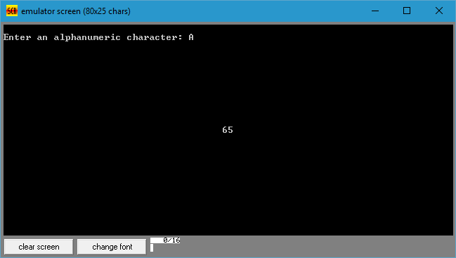

**Assembly Level Program 5a – Palindrome Checker**

Write an ALP to reverse a given string and check whether it is a palindrome or not.

**Program**

.model SMALL

PRINTSTR MACRO MSG

LEA DX, MSG

MOV AH, 09h

INT 21h

ENDM

READSTR MACRO BUF

LEA DX, BUF

MOV AH, 0Ah

INT 21h

ENDM

.data

BUF1 dB 20d

LEN1 dB ?

STR1 dB 20d DUP(0)

RSTR dB 20d DUP(0)

MSG1 dB 10, 13, 'Enter a String: $'

MSG2 dB 10, 13, 'String is a Palindrome!$'

MSG3 dB 10, 13, 'String is not a Palindrome!$'

.code

MOV AX, @DATA

MOV DS, AX

MOV ES, AX

PRINTSTR MSG1

READSTR BUF1

LEA SI, STR1

DEC SI

MOV CX, 00h

MOV CL, LEN1

ADD SI, CX

MOV DI, SI

LEA SI, RSTR

CopyString:

MOV AL, [DI]

MOV [SI], AL

INC SI

DEC DI

LOOP CopyString

LEA SI, STR1

LEA DI, RSTR

MOV CX, 00h

MOV CL, LEN1

CLD ; Clear Direction Flag

REPE CMPSB

JE Palindrome

PRINTSTR MSG3

JMP Exit

Palindrome:

PRINTSTR MSG2

Exit:

MOV AH, 4Ch

INT 21h

END

**Output**

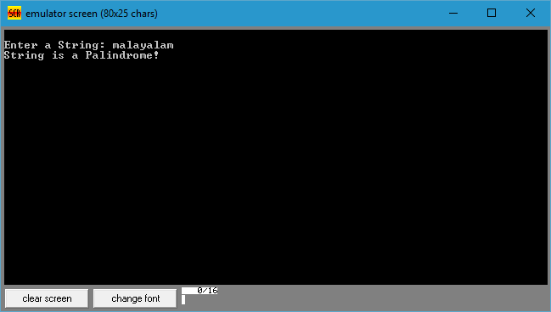

**Assembly Level Program 6a – String Equality**

Write an ALP to read two strings, store them in locations STR1 and STR2. Check whether they are equal or not and display appropriated messages. Also display the length of the stored strings.

**Program**

.model SMALL

PRINTSTR MACRO MSG

LEA DX, MSG

MOV AH, 09h

INT 21h

ENDM

READSTR MACRO BUF

LEA DX, BUF

MOV AH, 0Ah

INT 21h

ENDM

.data

BUF1 dB 20d

LEN1 dB ?

STR1 dB 20d DUP(0)

BUF2 dB 20d

LEN2 dB ?

STR2 dB 20d DUP(0)

MSG1 dB 10, 13, 'Enter String 1: $'

MSG2 dB 10, 13, 'Enter String 2: $'

MSG3 dB 10, 13, 'Length of String 1: $'

MSG4 dB 10, 13, 'Length of String 2: $'

MSG5 dB 10, 13, 'Strings are Equal!$'

MSG6 dB 10, 13, 'Strings are Not Equal!$'

.code

MOV AX, @DATA

MOV DS, AX

MOV ES, AX

PRINTSTR MSG1

READSTR BUF1

PRINTSTR MSG2

READSTR BUF2

MOV CL, LEN1

CMP CL, LEN2

JNE NotEqual

LEA SI, STR1

LEA DI, STR2

MOV CH, 00h

MOV CL, LEN1

CLD ; Clear Direction Flag

REPE CMPSB ; Compare String Byte-by-Byte

JE Equal

NotEqual:

PRINTSTR MSG6

JMP Exit

Equal:

PRINTSTR MSG5

Exit:

MOV AH, 4Ch

INT 21h

END

**Output**

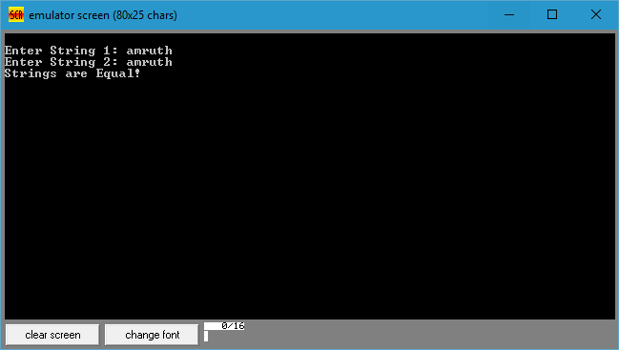

**Assembly Level Program 7a – What Is Your Name?**

Write an Assembly Level Program to read your name from the keyboard and display it at a specified location on the screen in front of the message What is your name?  
You must clear the entire screen before display.

**Program**

.model SMALL

READCH MACRO LOC

MOV AH, 01h

INT 21h

MOV LOC, AL

ENDM

CLRSCR MACRO

MOV AH, 00h

MOV AL, 03h

INT 10h

ENDM

SETCURSOR MACRO

MOV AH, 02h

MOV BH, 00h

MOV DH, 2

MOV DL, 20

INT 10h

ENDM

.data

MSG1 dB 10, 13, 'Enter your name: $'

MSG2 dB 10, 13, 'What is your name? $'

ARRAY dB 40h DUP(?)

.code

MOV AX, @DATA

MOV DS, AX

MOV SI, 00h

LEA DX, MSG1

MOV AH, 09h

INT 21h

ReadName:

READCH ARRAY[SI]

INC SI

CMP AL, 13

JNZ ReadName

MOV ARRAY[SI], '$'

CLRSCR

SETCURSOR

LEA DX, MSG2

MOV AH, 09h

INT 21h

MOV SI, 00h

DisplayName:

LEA DX, ARRAY[SI]

MOV AH, 09h

INT 21h

MOV AH, 4Ch

INT 21h

END

**Output**

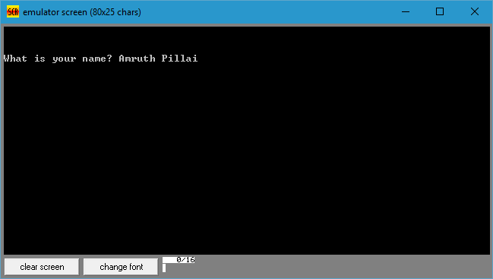

**Assembly Level Program 8a – Calculate NCR**

Write an Assembly Level Program to compute nCr using recursive procedure. Assume that ‘n’ and ‘r’ are non-negative integers.

**Program**

.model SMALL

.data

N dB 05d

R dB 02d

NCR dW ?

.code

MOV AX, @DATA

MOV DS, AX

MOV AX, 00h

MOV AL, N

MOV BL, R

MOV NCR, 00h

CALL NCRProcedure

MOV AH, 4Ch

INT 21h

NCRProcedure PROC

CMP AX, BX

JE IncrementBy1

CMP BX, 00h

JE IncrementBy1

CMP BX, 01h

JE IncrementByN

DEC AX

CMP AX, BX

JE IncrementBoth

PUSH AX

PUSH BX

CALL NCRProcedure

POP BX

POP AX

DEC BX

PUSH AX

PUSH BX

CALL NCRProcedure

POP BX

POP AX

RET

IncrementBy1:

INC NCR

RET

IncrementByN:

ADD NCR, AX

RET

IncrementBoth:

ADD NCR, AX

INC NCR

RET

NCRProcedure ENDP

END

**Output**

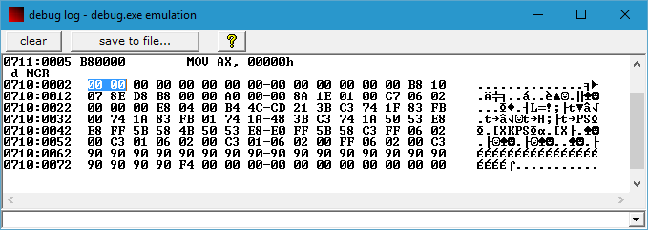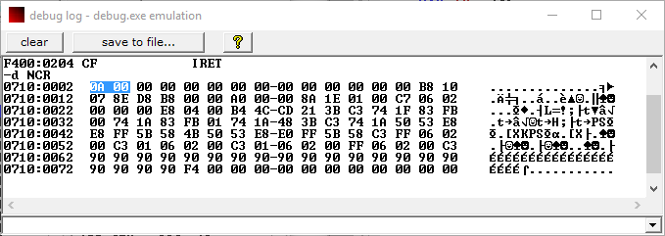

**Assembly Level Program 9a – System Time**

Write an Assembly Level Program to read the current time from the system and display it in the standard format on the screen.

**Program**

.model SMALL

DISPLAY MACRO

AAM ; BCD Adjustment After Multiplication

MOV BX, AX

MOV DL, BH

ADD DL, 30h

MOV AH, 02h

INT 21h

MOV DL, BL

ADD DL, 30h

MOV AH, 02h

INT 21h

ENDM

COLON MACRO

MOV DL, ':'

MOV AH, 02h

INT 21h

ENDM

.data

MSG1 dB 10, 13, 'The Current System Time is $'

.code

MOV AX, @DATA

MOV DS, AX

LEA DX, MSG1

MOV AH, 09h

INT 21h

; Interrupt to Fetch System Time

; CH - Hours | CL - Minutes | DH - Seconds | DL - Miliseconds

MOV AH, 2Ch

INT 21h

MOV AL, CH

DISPLAY

COLON

MOV AL, CL

DISPLAY

COLON

MOV AL, DH

DISPLAY

MOV AH, 4Ch

INT 21h

END

**Output**

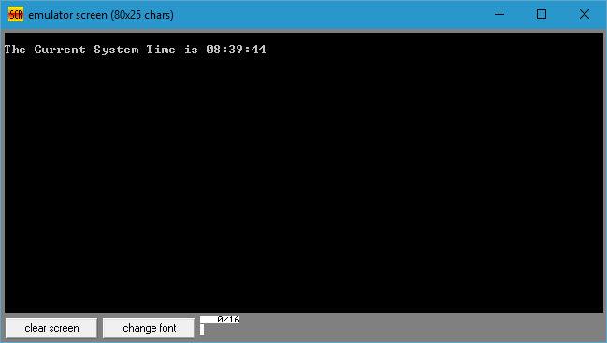

**Assembly Level Program 10a – Decimal Up Counter**

Write an Assembly Level Program to simulate a Decimal Up Counter to display 00 to 99.

**Program**

.model SMALL

.code

MOV AL, 30h

FirstLoop:

MOV DL, AL

MOV AH, 02h

INT 21h

PUSH AX

MOV BL, 30h

SecondLoop:

MOV DL, BL

MOV AH, 02h

INT 21h

INC BL

; Set Cursor to 2nd Column

MOV AH, 02h

MOV DL, 01h

INT 10h

CMP BL, 039h

JLE SecondLoop

; Set Cursor to 1st Column

MOV AH, 02h

MOV DL, 00h

INT 10h

POP AX

INC AL

CMP AL, 039h

JLE FirstLoop

MOV AH, 4Ch

INT 21h

END

**Output**

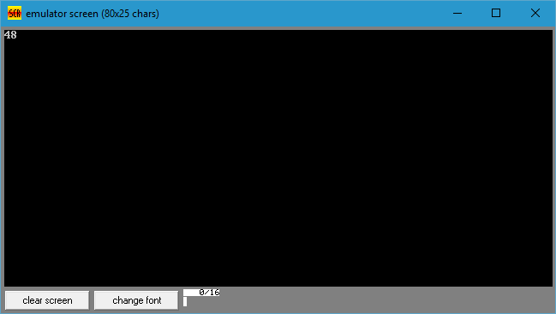

**Assembly Level Program 11a – Cursor Movement**

Write an Assembly Level Program to read a pair of input co-ordinates in BCD and move the cursor to the specified location on the screen.

**Program**

.MODEL SMALL

.DATA

XMSG DB 13,10,'ENTER VALUE OF X CO-ORDINATES:','$'

X DB ?

YMSG DB 13,10,'ENTER VALUE OF Y CO-ORDINATES:','$'

Y DB ?

.CODE

MOV AX,@DATA

MOV DS,AX

MOV DX,OFFSET XMSG ;TO READ BCD CO=ORDINATES

CALL READ_BCD

MOV X,BH

MOV DX,OFFSET YMSG

CALL READ_BCD

MOV Y,BH

MOV AH,02H ;TO SET CURSOR POSITION

MOV DH,X

MOV DL,Y

MOV BH,0

INT 10H

MOV DL,'-'

MOV AH,06H

INT 21H

MOV AH,4CH

INT 21H

READ_BCD PROC

MOV AH,09H

INT 21H

MOV AH,01H ;FIRST DIGIT

INT 21H

MOV BH,AL

MOV AH,01H ;SECOND DIGIT

INT 21H

MOV BL,AL

MOV CL,4H

SUB BH,30H ;TO CONVERT FROM ASCII TO BCD

SUB BL,30H

SHL BH,CL

OR BH,BL

RET

READ_BCD ENDP

END

**Output**

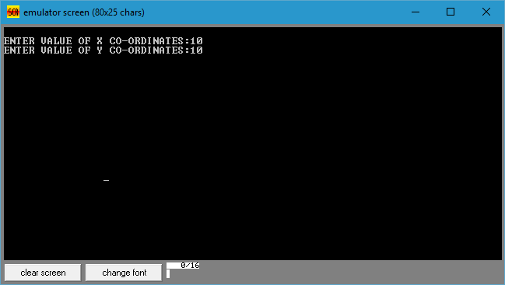

**Assembly Level Program 12a – File Handling**

Write an Assembly Level Program to create a file (input file) and to delete an existing file.

**CreateFile.asm**

.model SMALL

.data

FNAME dB 'SampleFile.txt', 00h

SUCCESS dB 10, 13, 'File has been created successfully!$'

FAILURE dB 10, 13, 'An Error Occurred during File Creation!$'

.code

MOV AX, @DATA

MOV DS, AX

MOV CX, 20h

; Interrupt to Create a File

LEA DX, FNAME

MOV AH, 3Ch

INT 21h

JC ErrorOccurred

LEA DX, SUCCESS

MOV AH, 09h

INT 21h

JMP Exit

ErrorOccurred:

LEA DX, FAILURE

MOV AH, 09h

INT 21h

Exit:

MOV AH, 4Ch

INT 21h

END

**Output**

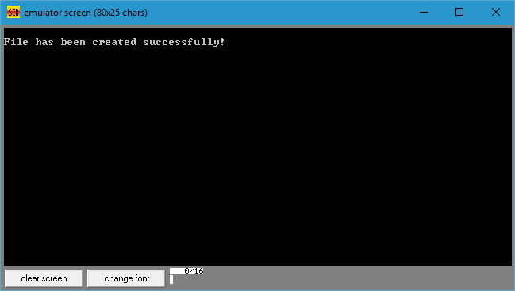

**DeleteFile.am**

.model SMALL

.data

FNAME dB 'SampleFile.txt', 00h

SUCCESS dB 10, 13, 'File has been deleted successfully!$'

FAILURE dB 10, 13, 'An Error Occurred during File Deletion!$'

.code

MOV AX, @DATA

MOV DS, AX

MOV CX, 20h

; Interrupt to Delete a File

LEA DX, FNAME

MOV AH, 41h

INT 21h

JC ErrorOccurred

LEA DX, SUCCESS

MOV AH, 09h

INT 21h

JMP Exit

ErrorOccurred:

LEA DX, FAILURE

MOV AH, 09h

INT 21h

Exit:

MOV AH, 4Ch

INT 21h

END

**Output**

